Regional differences in women’s part time employment
An analysis of supply and demand

Cuadrado-Roura, Juan R. *
Iglesias-Fernandez, Carlos **
Llorente-Heras, Raquel ***

University of Alcala. Madrid
Institute of Economic and Social Analysis.
Autónoma University of Madrid.

Abstract:

Part-time employment has a significant weight in the EU countries, but with remarkable differences. In The Netherlands, for instance, it reaches really high levels (50 per 100 of employment) whereas it has a comparative low weight in other countries like Spain (11.3 per 100). On the other hand, gender differences are also very significant, as well as their regional distribution, as it is the case of Spain. While women’s part-time employment in the Balearics is 16.4 per 100, in Navarre it reaches 27.8 per 100 (LFS, Active Population Survey, 3rd. quarter 2006). Focusing on women’s part-time employment, the paper has two main objectives. First, to compare its evolution in the main EU countries, showing the characteristics and reasons for their differences. Second, to analyze the factors supporting regional heterogeneity, taking Spain as a case-study. As opposed to the most usual approaches, focused either on the supply or the demand side of labour market, the paper adopts both perspectives considering that they are complementary in order to explain part-time employment levels as well as their spatial distribution.

Key words: part-time employment; European Union; women; regional disparities; Spanish case.
JEL classification: J16, J22, R12.

______________________

* E-m : jr.cuadrado@uah.es
** E-m: carlos.iglesias@uah.es
*** E-m: raquel.llorente@uah.es

Address : Instituto de Análisis Económico y Social.
Universidad de Alcalá
Plaza de la Victoria, 1.
28802 Alcala de Henares. Madrid. Spain.

1. Introduction and general proposals.

The analysis of part-time employment (PTE) is of great importance in Labor Economy, especially in relation with women’s employment.

Firstly, part-time employment has registered important growth, in both Spain as well as the European Union (UE-15). In Spain the rate of part-time employment increased from 7.4 percent in 1995 to 12.2 percent in 2006; for women, growth rose from 16.5 percent in 1995 to 23.5 percent in 2006. In the UE-15 the rate of part-time employment increased from 16 percent in 1995 to 20.9 percent in 2006, and the rate for women, which in 1995 stood at 31.3 percent, stood at 36.9 percent in 2006.

Secondly, due to its relation with the emergence of what has been called “the new work models” (Ducatel, 1994), which substitute those in force up until recently, and which would involve the stimulus of part-time employment as an instrument in order to obtain flexibility in the management of product supply and the organization of work processes.

Thirdly, PTE is a central element in the redefinition of the concept of full employment proposed by the “transitional labor markets” hypothesis (Schmid, 1998) (Schmid and Gazier, 2002) (O´Reilly, Cebrián and Lallement, 2000).

Lastly, the part-time employment maintains a close relationship with women’s paid labor. Based on the differentiation between the spheres of market and domestic production (Carrasco, 2006) PTE is related with the the need women have of balancing family life with the demands of the market, a requirement for their decision to participate the labor market. This consideration is particularly relevant, to the extent to which PTE is set up as a central tool of Employment Policy framework, aimed at stimulating labor participation, especially of women, through a balance of paid work and work done at home. (VVAA, 2005). Nevertheless, the relation between PTE and women is not without difficulties, if this contractual type turns into an instrument for the confinement of women to determined segments of the labor market (Connolly and Gregory, 2005) of low productvity and of worse labor conditions (Bollé, 1997).

On the basis of the above arguments, and using the Spanish case as reference, the purpose of this paper is to determine the factors which from the supply side and the demand side explain the observed regional differences of women’s part-time employment.

To this end, section 2 below presents the subject, indicating the factors shaped by PTE in the EU. The theoretical framework is established in section 3, the methodological approach of analysis is included in section 4 and the obtained results are provided in section 5. The paper ends with a compilation of the principal results in section 6.

The study uses two data sources. The Labour Force Survey drawn up by Eurostat (1987 to 2005) and the Labor Force Survey (1997 to 2006), carried out by the National Statistics Institute in Spain.

2. Women’s part-time employment in the European Union.

The purpose of this section is to undertake a descriptive analysis of part-time employment in the European Union, as a means of underscoring some of its fundamental characteristics, and of placing Spain within the European context. .

Figure 1. Part-time employment rates for women by percentage.
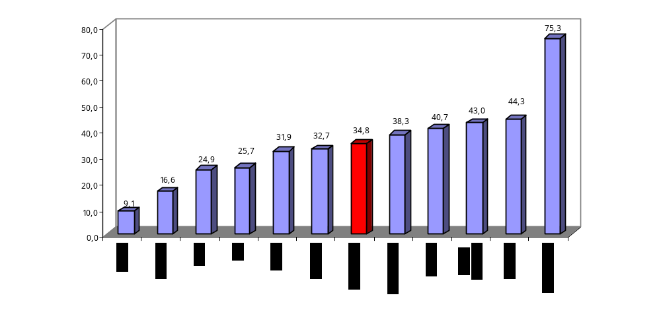
Source: Labour Force Survey. 2nd Quarter 2005, except Ireland, 2004.

Figure 2.Growth rate of part-time employment rates for women by country.
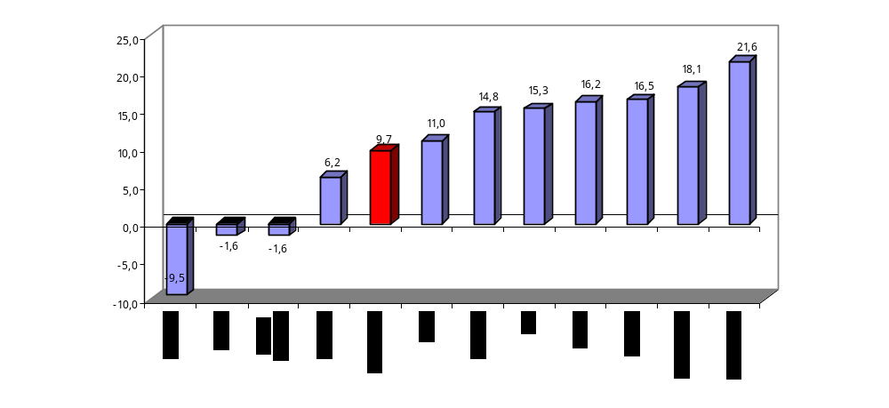
Source: Labour Force Survey. 2nd Quarter 1987 and 2005.

As can be observed in figure 1, women’s part-time employment is amply spread throughout the EU, although with differences among countries. Spain is one of the countries with one of the lowest part-time employment rates, and is only ahead of Greece and Portugal, which have lower figures. Nevertheless, Spain presents PTE growth which is slightly higher than the EU aggregate (Figure 2). This result is produced, besides, within a context of general development characterized by elevated national growth patterns.

In each and every one of the European countries, PTE is predominantly for women (Figure 3). In Spain approximately 78 percent of part-time employees are women, a figure which exceeds the European average. Therefore, the analysis of the factors that explain regional differences observed in part-time employment must differentiate between the aggregate situation and the one specific to women. This approach will be carried out in the next section.

Figure 3. Percentage of women over total part-time employment.
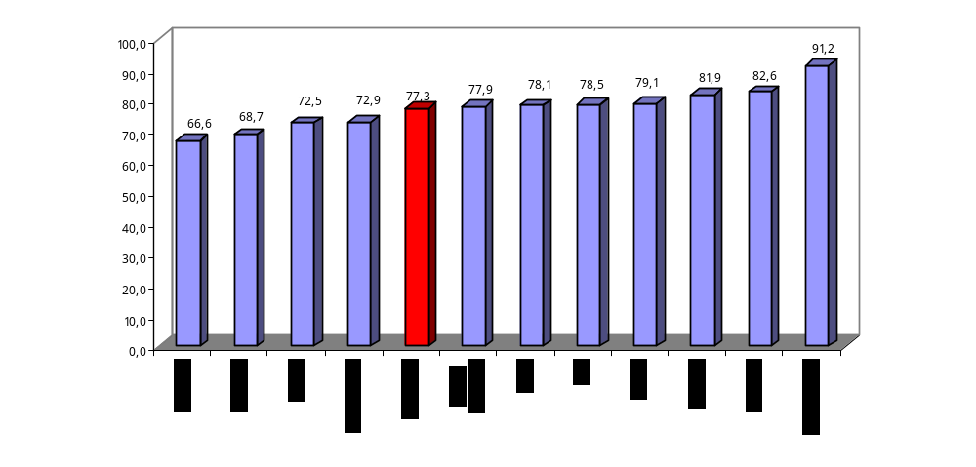
Source: Labour Force Survey. 2nd Quarter 2005.

Nor is the feminine collective homogenous, presenting notable differences in its composition. In this sense, Table 1 distinguishes between the distribution of women’s part-time employment by age brackets. According to the average distribution shown in the bottom row, part-time employment is higher among women between the ages of 25 and 49 years old, which in terms of the life cycle is related with bearing and raising children, as well as with the need to balance their work and family life. In the case of Spain, women use use part-time employment with greater intensity than European women in the indicated age bracket, as well as between 15 and 24 years of age. Therefore, it seems that part-time employment in Spain is set up as an instrument to balance work and family life, equal to the situation in the EU, but also as an instrument that favors the entry of young women into the work force.

The second variable that must be considered is the level of studies (Table 2). In the EU, the use of part-time employment is greater among women with a high school or elementary education. In Spain women’s part-time employment is related more intensely with studies at a lower level, something which also occurs in Greece and above all in Portugal.

Table 1. Distribution by percentage of women’s part-time employment by age brackets.
 | Between 15 and 24 | Between 25 and 49 | 50 years and over | Total
Belgium | 7,1 | 72,2 | 20,6 | 100,0
Denmark | 29,1 | 46,0 | 24,9 | 100,0
Germany | 5,9 | 66,3 | 27,8 | 100,0
Ireland | 16,7 | 58,9 | 24,4 | 100,0
Greece | 13,2 | 62,5 | 24,3 | 100,0
Spain | 14,7 | 68,2 | 17,1 | 100,0
Italy | 7,1 | 77,9 | 15,0 | 100,0
Luxembourg | 3,1 | 75,0 | 21,9 | 100,0
Netherlands | 17,5 | 60,3 | 22,2 | 100,0
Portugal | 6,6 | 39,8 | 53,6 | 100,0
United Kingdom | 14,2 | 56,3 | 29,5 | 100,0
Average | 12,3 | 62,1 | 25,6
Source: Labour Force Survey. 2nd Quarter 2005.

Table 2. Distribution by percentage of women’s part-time employment by level of studies.
 | Pre-primary, primary and lower secondary education | Upper secondary and post-secondary non-tertiary education | Tertiary  education | Total
Belgium | 27,3 | 40,9 | 31,8 | 100,0
Denmark | 28,6 | 43,4 | 27,9 | 100,0
Germany | 19,2 | 63,7 | 17,1 | 100,0
Ireland* | 35,0 | 43,2 | 21,8 | 100,0
Greece | 42,1 | 40,1 | 17,8 | 100,0
Spain | 47,4 | 25,4 | 27,2 | 100,0
Italy | 39,5 | 48,7 | 11,8 | 100,0
Luxembourg | 32,3 | 45,2 | 22,6 | 100,0
Netherlands | 28,7 | 44,5 | 26,8 | 100,0
Portugal | 86,5 | 6,9 | 6,6 | 100,0
United Kingdom | 14,2 | 63,3 | 22,5 | 100,0
Average | 36,4 | 42,3 | 21,3
Source: Labour Force Survey. 2nd Quarter 2005.

Table 3. Distribution of women’s part-time employment by occupation and labor sector.
 | Belgium | Denmark | Germany | Ireland * | Greece | Spain | Italy | Luxemb. | Netherlands | Portugal | U. Kingdom | Average
Occupations
Legislators, senior officials and managers | 4,1 | 1,2 | 1,2 | 6,1 | 2,0 | 2,1 | 3,1 | 3,2 | 4,0 | 3,1 | 4,7 | 3,2
Professionals | 20,8 | 7,6 | 10,3 | 14,6 | 15,7 | 10,5 | 6,5 | 16,1 | 17,6 | 5,1 | 8,1 | 12,1
Technicians and associate professionals | 11,3 | 20,4 | 22,7 | 5,3 | 4,6 | 9,3 | 18,1 | 22,6 | 20,7 | 2,0 | 11,2 | 13,5
Clerks | 22,1 | 13,3 | 18,6 | 21,1 | 10,5 | 12,0 | 19,3 | 19,4 | 19,7 | 5,1 | 23,1 | 16,7
Service and shop and market sales workers | 20,8 | 36,4 | 24,8 | 37,0 | 22,2 | 26,2 | 22,3 | 12,9 | 24,2 | 9,7 | 36,8 | 24,9
Skilled agricultural and fishery workers | 0,8 |  | 1,2 |  | 22,2 | 1,6 | 1,4 |  | 1,0 | 40,8 | 0,2 | 8,7
Craft and related trades workers | 1,1 |  | 2,6 | 1,2 | 2,0 | 2,4 | 6,3 |  | 0,8 | 3,1 | 0,7 | 2,2
Plant and machine operators and assemblers | 2,3 |  | 1,9 | 1,6 |  | 1,3 | 2,7 |  | 1,0 |  | 1,2 | 1,7
Elementary occupations | 16,8 | 21,1 | 16,7 | 13,0 | 20,9 | 34,5 | 20,3 | 25,8 | 10,9 | 31,1 | 13,8 | 20,5
TOTAL | 100,0 | 100,0 | 100,0 | 100,0 | 100,0 | 100,0 | 100,0 | 100,0 | 100,0 | 100,0 | 100,0 | 100,0
Sectors of activities
Agriculture, hunting, forestry and fishing | 0,9 | 2,2 | 1,5 | 1,6 | 23,3 | 3,3 | 2,5 |  | 2,4 | 42,4 | 0,7 | 8,1
Industry | 8,1 | 7,3 | 13,2 | 7,7 | 5,3 | 8,4 | 13,1 | 6,5 | 7,5 | 5,7 | 6,3 | 8,1
Services (excluding Public Administration) | 33,2 | 34,8 | 41,6 | 47,0 | 32,7 | 44,9 | 47,6 | 35,5 | 37,6 | 21,1 | 43,6 | 38,1
Public Adm., Defense, social security | 10,5 | 2,9 | 6,0 | 3,2 |  | 2,3 | 3,3 | 12,9 | 5,1 |  | 5,2 | 5,7
Other services | 47,3 | 52,8 | 37,7 | 40,5 | 38,7 | 41,1 | 33,5 | 45,2 | 47,5 | 30,8 | 44,2 | 41,7
TOTAL | 100,0 | 100,0 | 100,0 | 100,0 | 100,0 | 100,0 | 100,0 | 100,0 | 100,0 | 100,0 | 100,0 | 100,0
Source: Labour Force Survey. 2nd Quarter 2005.

Another feature to highlight is that part-time employment is a resource used especially in service jobs (whether or not they are in this sector) and basic occupations (Table 3). Consequently, part-time employment is especially frequent in the tertiary sector, largely due to the fact that this either presents greater possibilities of flexibility for the organization of work processes, or to have a larger presence of feminine employment (Cecilia, C., et al, 2004).

Figure 3. Percentage of unwillingness over total women’s part-time employment.
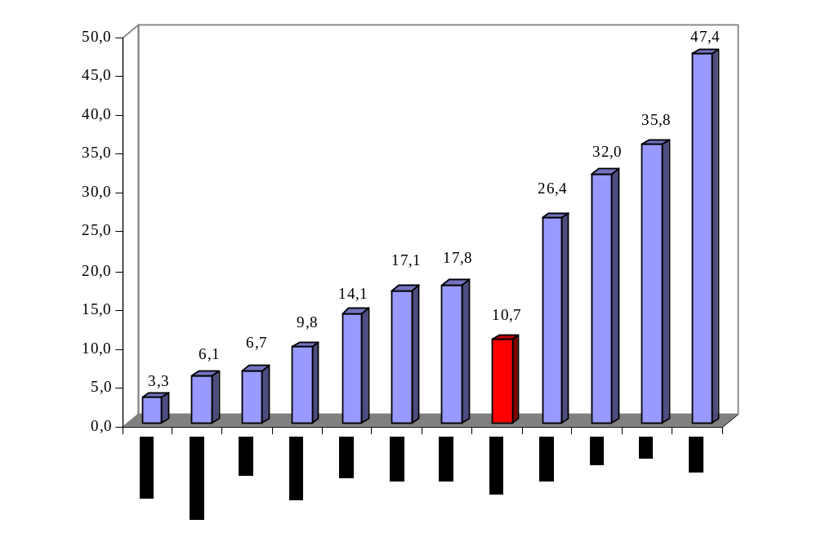 Source: Labour Force Survey. 2nd Quarter 2005.

Lastly, it is also a good idea to make reference to the willingness or unwillingness associated with jobs that have part-time shifts (Figure 3). The level of unwillingness in women’s part-time employment within the EU is not very high. Nevertheless, this does not occur in the case of Spain, where the percentage of unwillingness reaches 32 percent of women that are employed part-time, just under Italy and Greece again, and with similar levels as Portugal. Therefore, it seems clear that there are different national models related to part-time employment.

3. Theoretical framework

According to economic theory, the use of PTE is justified due to the fact that its use should result in an increase in the general rate of employment, by favoring positive effects both from the supply as well as the demand side of employment. In terms of supply, to the extent which it promotes an increase in the employment supply and, therefore, less salary pressure, by making it possible for certain collectives, previously outside the employment supply, to become part of it. In terms of demand, to the extent that it increases business possibilites of organizing work processes and flexibility in this regard, which will result in gains of productivity (O´Reilly, 1997).

Based on this general proposal, and to the extent that part-time employment is frequently considered to be an instrument for entry into the labor market, especially in relation with the feminine collective, its study normally has been approached from a perspective of supply. In this sense, the theories of the New Economics of the Family (Becker, 1981) provide the theoretical framework that is used most often. According to its proposals, the different members of the family distribute their time between work done at home and in the labor market, specializing in a rational way in that facet for which they are relatively more productive. Given that women are, for biological reasons, more efficient than men with regards to having and raising children, they dedicate a greater part of their time carrying out domestic tasks, and because of this their decisions regarding supply of paid work in the labor market will be conditioned by the possibilities of balancing family and work life.

Likewise, it is argued that when a woman make decisions about investing in Human Capital, she takes in to consideration the fact that her work trajectory will be shorter and more intermittent than that of men, and so it is considered efficient (rate of productivity) to invest a lower amount of resources in the acquisition of human capital. Lower investment in human capital will translate into lower rates of activity as well as employment. In this manner, women will also participate less than men in the training processes taking place in companies once they have taken the job position. These arguments could explain the lower average salaries of women, which also would lead us to understand that women find part-time employment more attractive than men.

Nevertheless, in the face of these proposals it is also argued that women take into consideration the fact that they are going to participate in a labor market that segregates and discriminates against them, which conditions them with respect to their decisions regarding investment in Human Capital (Rubery, Fagan and Maier, 1997; Humphries and Rubery, 1995).

In short, and if we consider, as a normal occurrence, the decisions to participate in the labor market as the consequence of search processes that lead to the determination of a stablish reserve salary, it can be affirmed that in the case of women, as compared to men, family variable such as marital status, having children and the age of their children, or the employment status of their husband, play a relevant role in the explanation of participation by women in the labor force and, beforehand, in their Human Capital acquisition processes (Juhn and Murphy, 1997; Spletzer, 1997, among many other papers written on this subject).

The main implication of the arguments above is that PTE would increase the possibilities of balancing that women dispose of, acting as a relevant element in the women’s decisions taken with respect to participating in the labor force, which would undoubtedly justify the fact that their analysis is preferably defined from the perspective of employment supply.

Nevertheless, the use of PTE as an instrument for stimulating the rate of activity of women and of improving their results in terms of employment is conditioned by the existence of this type of job position. That is, in order for PTE to be set up as an important tool for Labor Policy applied in favor of women, in addition to adjusting to the characteristics of the decision of supply made by this collective, it must fit within the schema of companies’s employment demand. Therefore it is necessary to analyze the determinants of use of PTE on the part of companies. From this standpoint, studies have been carried out adopting different analytical perspectives:

- The majority of research papers analyzes the role of wage costs in the business decision to demand part-time or full-time employment, determining whether the latter creates a better cost-productivity wage ratio (Roger and Roux, 2000).
- Possible differences in terms of non-wage complements and social benefits have also been taken into consideration (Buchmueller, 1999). Thus the business demand for PTE might be explained by the extent to which it presents a lower amount for these components in its labor costs. Even when both alternatives presented similar wage costs, they would differ in terms of total labor costs.
- The implications of the sectoral change on employment demand have also been considered as a possible motivator for business demand for this type of work (Fallick, 1999), determining to what extent the changes that have taken place in the sectoral structure of employment have benefitted part-time employment. In this regard, an attempt will be made to determine the final effect of, at least, two opposing arguments. On the one hand, services are more inclined to hire women. On the other, nevertheless, it is affirmed that tertiary activities are characterized by a lower divisibility of the work factor, to a great extent due to the “personal” nature itself of many services, which would act against part-time employment (Anxo and Storrie, 2000).
- Special interest has been placed on the relation that might exist between part-time work and the needs for flexibility. Companies might demand part-time employment as a way of bringing increased doses of flexibility to their operations. This analytical perspective has been carried out from different points of view:
  - Dynamic flexibility, understood as the relation of employment with the economic cycle (Buddelmeier, 2003). It is possible that businesses want to use PTE due to this labor figure’s having a more sensitive behavior cycle than full-time work.
  - Flexibility understood as the capability of companies to adjust (Friesen, 1997), therefore the desirability of part-time work would rest on the fact that it increases the capacity of firms to adapt to the consequences of economic shocks.
  - PTE has also been considered as a source of organizational flexibility for companies (Zeytinoglu, 1992), which becomes particularly relevant in productive activities with variations in product demand but which can be anticipated, either in sectors that operate in highly competitive markets, where flexibility in the organization could be especially relevant (flexibility of work schedules, time-tables…).

Complimentarily, some research papers attempt to carry out approaches wherein PTE analysis incorporates both perspectives (Columbino and Di Tommaso, 2000; Euwals and Hogerbrugge, 2004, Ehrenberg ,1988, among others).

A final explanatory possibility on the use of part-time work focuses, beyond the determinants of labor supply and demand, on the idea that its use responds to labor strategies of job segregation or segmentation. In this manner, part-time employment would stop being an employment opportunity for women, becoming instead a trap leading to their labor confinement and to the limiting of their professional careers (O`Reily and Bothfeld, 2002; Connolly and Gregory, 2005; Bollé, 1997).

From the first point of view presented above, the use of part-time work would act as an instrument that segregates workers on the basis of gender. According to the concentration hypothesis (Bergmann, 1986), company jobs, and, by aggregation, those of the labor market, would be diffrerentiated based on their definition as masculine or feminine. The result is that, whereas men can hold the majority of jobs, women are confined to a limited number of them, which would also imply low levels of productivity. Employers can derive benefits from segregation if this situation is found in conjunction with positive external economies. The individual productivity of workers may depend on the group relations established among workers on staff. Therefore it is possible that, under certain social conditions, segregation based on gender could bring higher levels of productivity to the company.

Alternately, part-time employment can also be set up as a segmentation instrument of the labor market. In this sense, it must be kept in mind that the segmentation hypothesis (Doeringer and Piore, 1971), based on a survey of the single job market, maintains its differentiation in a primary segment (good, stable jobs, with training, well-paid) and another secondary segment (instability, little or no training, poorly paid, poor work conditions). In some way, it is possible to state that the primary-secondary segment dichotomy would also correspond with the alternative of full or part-time employment. From this standpoint, the different explanatory theories of segmentation would also be applicable for understanding the use of part-time employment: stability or uncertainty associated with product demand (Piore and Berger, 1980); the differences in the labor supply, which by means of various social relations of production and their institutionalization in the firm, lead to differentiated and independent economic operations in the various sections of the labor market (Piore, 1975); change distribution policy and the inherent uncertainty of policy activity among different groups of workers (Piore and Berger, 1980).

4. Regional differences in Spanish part-time employment.

Based on the theoretical framework above, we can now begin our study of one case, and attempt not only to obtain empirical results, but also to offer a possible explanation of the facts and, above all, of the differences among regions.

In Spain important regional differences can be observed in the distribution of part-time work (Table 4). In the Spanish regions a generalized growth in part-time employment has occurred, accompanied at the same time by a reduction in regional differences as related to this matter. The Spanish regions with the greatest rate of part-time employment are Navarra, the Community of Valencia and Extremadura. Asturias and Castilla-La Mancha have the lowest rates of part-time employment.

Table 4. Rates of part-time employment in Spanish regions. Total employment and female population (Source: LFS, second quarter, 1997 and 2006).
 | Total |  |  | Women
 | 1997 | 2006 | Dif. | 1997 | 2006 | Dif.
Andalucía | 8,80 | 12,88 | 4,08 | 19,44 | 25,48 | 6,04
Aragón | 8,32 | 13,48 | 5,16 | 20,42 | 28,29 | 7,88
Asturias | 4,66 | 10,00 | 5,34 | 10,82 | 19,04 | 8,22
Baleares | 6,40 | 10,96 | 4,56 | 13,12 | 20,41 | 7,29
Canaries | 11,21 | 11,32 | 0,10 | 20,65 | 20,95 | 0,30
Cantabria | 7,12 | 10,48 | 3,36 | 15,57 | 21,22 | 5,65
Castille-León | 8,76 | 11,19 | 2,44 | 21,22 | 24,30 | 3,09
Castille-La Mancha | 7,18 | 10,05 | 2,87 | 18,61 | 23,52 | 4,91
Catalonia | 8,85 | 11,70 | 2,85 | 18,52 | 21,65 | 3,13
Community of Valencia | 11,27 | 14,86 | 3,59 | 23,44 | 28,48 | 5,05
Extremadura | 7,31 | 14,04 | 6,73 | 16,74 | 28,53 | 11,79
Galicia | 7,28 | 11,14 | 3,86 | 13,03 | 19,85 | 6,81
La Rioja | 6,56 | 13,85 | 7,29 | 14,21 | 29,66 | 15,46
Madrid | 4,76 | 10,79 | 6,04 | 10,08 | 20,03 | 9,96
Murcia | 8,12 | 13,12 | 5,00 | 18,56 | 26,22 | 7,66
Navarra | 9,51 | 15,27 | 5,76 | 22,63 | 28,84 | 6,21
Basque Country | 8,45 | 13,85 | 5,40 | 17,87 | 26,97 | 9,10
Ceuta and Melilla | 5,83 | 12,34 | 6,52 | 13,18 | 21,43 | 8,25
Total | 8,16 | 12,21 | 4,04 | 17,39 | 23,54 | 6,15
Average | 7,80 | 12,30 | 4,50 | 17,12 | 24,16 | 7,04
Variance | 3,43 | 2,78 |  | 15,95 | 13,53
Regions with higher rates than the average have been highlighted.

The part-time employment rate is notably higher in the case of women. In addition, the average growth of this rate is also higher, with an average of 7.04 points of difference for women as compared to 4.50 difference points for the total population. In the case of women, part-time employment rates are even greater in some regions as compared to others, although the regional differences in terms of women’s part-time work also experienced a reduction during the period under analysis. According to the most recent data, the Spanish regions with the highest rates of women’s part-time employment are La Rioja, Extremadura and the Community of Valencia, with values reaching nearly 30 percent, whereas Galicia and Asturias do not reach 20 percent.

4.1Empirical approach.

Our goal is to determine the factors that explain the regional differences in terms of PTE using both a perspective of supply as well of demand. In order to do so we will make estimations that take jointly into account both types of variables. The base equations are the following (Ehrenberg, 1988; Euwals and Hogerbrugge (2004):

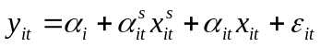 (1)
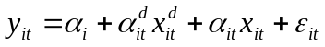 (2)
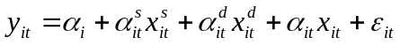 (3)

where equation 1 reflects how the factors of supply and some exogenous variables influence the rate of part-time employment (y) at the regional level (i) and throughout time (t); equation 2 takes in the effects of demand; and equation 3 takes in the combined effects taking into account supply and demand. The part-time employment rate has been calculated as the percentage of part-time workers over the total number of workers. In order to differentiate part-time from full-time work, the information provided by the LFS (Labor Force Survey) on working hours has been used.

In line with the theoretical arguments above (Section 3), the variable used for supply and its interpretation are the following:

  - The percentage of women over the total population in the region. To the extent that PTE is intensely related with women’s employment, a positive sign would be expected in this variable, thus PTE increases by making it the percentage of women.
  - the percentage of women between the ages of 16 and 44 (young women). It would be expected that in those regions where there is a greater percentage of young women there would be a greater the rate of part-time employment. Just as Figure A.1 shows (see annex), the composition of the rate of part-time employment in the Spanish population by age shows a certain preference for young people over mature adults or over those nearing retirement age. On the other hand, PTE should be a tool used to balance home and work life, used therefore preferentially by young women or women with children.
  - the percentage of men between the ages of 16 and 44 (young men). Following the above reasoning but in the reverse direction, the existence of a significant collective of young men should determine a lower rate of regional part-time employment due to this collective’s giving preference to full-time work, at the same time that family behavior patterns with a greater tendency of sharing household chores in the family nucleus may appear.
  - the percentage of mothers over the total population. Using the data provided by the LFS mothers have been defined as those women that live with children in the household and who are the head of the family or those women that live with children in the home and who are the partner of the head of family. Therefore, with the data from the LFS we cannot differentiate between children that live in the household and natural children, but in any case we establish that there are situations of dependence that require the balancing of home and work life and therefore the woman may turn to part-time employment. The fact of being a mother should increase the demands of balancing home and work and, therefore, the need for PTE.
  - percentage of students over the total population understanding students as any person that is inactive due to their being enrolled in studies. To the extent that students also make up a collective that is particularly tied to PTE, an increase in their presence should stimulate the presence of PTE.

On the demand side, the variables included are the following:

  - the percentage of employment in services over the sum total of employment in each one of the regions throughout time. Its interpretation is ambiguous. On the one hand, and if we allow for its lower capacity for organizing work processes in a flexible way, its effect on PTE should be negative. On the other hand, and to the extent that tertiary activities are predominantly for women, the effect should have the opposite sign.
  - the Duncan-Duncan segregation index, which is established on 9 sectors of activity and which determines in which markets of regional employment there is greater horizontal segregation of women. The inclusion of this variable is due to the desire of establishing whether segregation of women is carried out against jobs associated with being more part-time in nature and, as a result, if it is possible to determine that in the regions where there is greater segregation a greater presence of part-time work would be expected. If this were so, a greater segregation should imply a greater presence of PTE.
  - the forecast of businessmen on the future development of their available staff in the upcoming quarter, according to the data of the Survey of Labor Conditions. This variable is used as an approximation of the expectations of businessmen with respect to the future development of the context of activity and of the labor market. It would be expected that the more intense the resort to PTE would be, the greater would be the expected hiring needs of companies.
  - the percentage of employment related with R&D activities over total employment. This variable attempts to approximate the degree of economic development and the type of existing productive structure, so that we will be able to the relation between PTE and the regions that are most advanced and related with the NIT.
  - the average difference between hours normally worked and effective hours worked. If this difference is high it indicates that the productive structure of the region requires a high level of flexibility in work schedules, so it would be expected that the amount of part-time work would also be high.
  - productivity, understanding productivity to be average productivity or total productivity in relation with total employment, based on the connection of GDP series provided by the Spanish Regional Accountancy. The interpretation of this variable is also ambiguous. From the perspective of the argument of segregation, PTE should be related with jobs that are not very productive. On the other hand, the most productive activities can require more PTE if this is related with possibilities of organizational flexibility and activity.
  - and the percentages of job vacancies over the total population in each region. This variable reflects the degree of economic imbalance in the regional labor market. An attempt would be made to determine to what extent this imbalance becomes more balanced by means of part-time employment. At the same time it is also an indicative variable of the economic cycle. Therefore if job vacancies increase and PTE also increases we can determine that part-time employment is an adjustment tool for the economic cycle of the labor market.

Finally, in all of the models a series of exogenous or control variables have been maintained in order to demonstrate that the estimations maintain consistent results:

  - a temporal variable constructed over the period 1997-2006 so that the base year is zero, which attempts to capture the sensitivity of PTE to the economic cycle.
  - and the percentage of women over the total population, given that the female population tends to be employed more frequently in part-time jobs, as defined above.

In the annex at the end of this paper a table is included that defines each one of the variables used in relation with their abbreviation and the original source of the data.

4.2 Main results.

Our strategy has consisted first of all making an estimation for the set of PTE in order to subsequently specify the analysis for the specific case of women. From an econometric standpoint, the estimations have been made in line with different methodologies: OLS, instrumental variables and panel models.

- Determinants of the regional differences of PTE (both types).

Table 5 shows the results reached by estimating equations (1) to (3) for the Spanish regions and the total PTE (men and women) by ordinary least squares, with dummy variables for the autonomous communities and the time trend variable. The estimations have been weighted for the total population of each region, so the size of the region is taken into account.

In relation with the model established by the supply side, the variables that are significant are the time trend variable, the percentage of young men and the percentage of mothers. In accordance with the coefficients obtained, to the extent that time increases, the rate of part-time employment shows growth in the Spanish regions, in those regions where there is a greater percentage of young men the rate of part-time employment is less and in those regions where the percentage of mothers is high the rate of part-time employment is higher. The rest of the supply variables are not significant.

Table 5. Estimation by weighted OLS to regional distribution of part-time employment from supply, demand and both sides. (Source: Owner elaboration)
 | Supply side model |  | Demand side model |  | Both side model
 | Coef. | Std. Err.  (Sig.) | Coef. | Std. Err. (Sig.) | Coef. | Std. Err. (Sig.)
Time (1997=0) | 0.167 | 0.055**  (0.003) | 0,172 | 0,058**  (0,004) | 0,013 | 0,643  (0,837)
M_pt | 0.188 | 0.955  (0.844 ) | 2,117 | 0,925**  (0,024) | 0,265 | 0,832  (0,750)
M1644_pt | 0.585 | 0.368  (0.114 ) |  |  | 0,658 | 0,375*  (0,082)
H1644_pt | -0.835 | 0.333**  (0.013) |  |  | -1,097 | 0,326**  (0,001)
pmother | 0,324 | 0,043**  (0,000) |  |  | 0,431 | 0,068**  (0,000)
Est_pt | 2,585 | 2,984  (0,388) |  |  | -5,234 | 5,368  (0,331)
Pss |  |  | 0,386 | 0,077**  (0,000) | 0,175 | 0,068**  (0,011)
isegre |  |  | -1,409 | 6,306  (0,823) | -3,800 | 4,746  (0,425)
prequar |  |  | 0,135 | 0,112  (0,231) | 0,006 | 0,102  (0,947)
Pi_d_et |  |  | 0.110 | 0,444**  (0,014) | 0,946 | 0,518*  (0,066)
dhours |  |  | 0,559 | 0,194**  (0,005) | 0,640 | 0,151**  (0,000)
prod |  |  | -0,105 | 0,104  (0,316) | -0,082 | 0,097*  (0,398)
Vac_pt |  |  | 0,032 | 0,104  (0,926) | 0,055 | 0,717  (0,491)
Constant | -5,546 | 49,296  (0,911) | -92,484 | 46,680**  (0,049) | -9,655 | 0,426  (0,821)
Number of obs |  | 170 |  | 170 |  | 170
F( 22, 147) |  | 27.47 | F( 25, 144) | 20,56 | F( 29, 140) | 29,95
Prob > F |  | 0.0000 |  | 0,0000 |  | 0,0000
R-squared |  | 0.7851 |  | 0,7561 |  | 0,8417
Root MSE |  | 1.1487 |  | 1,236 |  | 1,0103
* Significant with a probability of 90 %. ** Significant with a probability of 95 %. Not included the variables of regions generated by the model. Order in STATA:
Model to demand side: xi: regress ep_et time m_pt m1644_pt h1644_pt pmother est_pt i.ccaa2 [pweight=pt], robust
Model to supply side:xi: regress ep_et time m_pt pss isegre pretri pi_d_et djornada prod9706 vac_pt i.ccaa2 [pweight=pt], robust. Model to both sides: xi: regress ep_et time m_pt m1644_pt h1644_pt pmother est_pt pss isegre pretri pi_d_et djornada prod9706 vac_pt i.ccaa2 [pweight=pt ], robust

On the demand side, the determinant variables of the rate of part-time employment are: the temporal variable, the percentage of services, the percentage of employment in R&D over the total employment and the difference between normal hours and effective hours worked.

The regions with a greater percentage of employment in the tertiary sector are also those that have a greater percentage of part-time employment. This result contradicts the basic theoretical assumptions established by Anxo and Storrie (2000), which maintain that lesser flexibility of tertiary activities results in less part-time employment. An explanation for this can come from two paths. In the first place, it is possible that the tertiary activities are more flexible in the Spanish economy, and therefore favor part-time employment. This explanation is coherent with the makeup of our tertiary employment, where tourist activities and personal and domestic services tend to be developed preferentially by means of part-time and temporary jobs. In the second place, given the correlation between tertiary activities and women’s employment, this result would be reflecting the fact that there is more PTE where there are more services due to this type of work’s being done more frequently by women.

The model establishes a positive relation betwen the percentage of employemnt in R&D and PTE. The regions with a more advanced productive structure, in the sense of dedicating a greater percentage of labor resources to R&D activities, are also the ones that have greater flexibility with employment and, as a result, a greater percentage of part-time employment.

Finally, the difference between effective hours and normal hours also brings a significant positive result. The regions with productive structures characterized by having greater needs for and possibilities of organizational flexibility resort to PTE as a way to achieve this.

The last column in Table 5 shows the estimation of the complete model considering both the demand side as well as the offer side. In this model, the greater part of the variables that are significant have already been commented on above. With the complete estimation, the percentage of young women and productivity are added to the Spanish economy.

The first variable indicates that where there is a greater percentage of young women (between 16 and 44 years of age) part-time employment is greater, which coincides with that which is stated in theory. The fact that men and women obtain results of different signs confirms that women find PTE more attractive than men do, which must have a clear interpretation in terms of the way in which tasks are organized within families.

In the second place, productivity shows that in regions where productivity is greater, the rate of PTE is lower. The interpretation of this result is complicated, and for this reason it must be carried out with great caution. It could be reflecting some type of correlation that is not monitored by the model (i.e., differences of productivity by gender, sectoral differences of productivity).

- Determinants of the regional differences in women’s PTE.

Given the existing relation betwen PTE and women’s employment, the same equations have been estimated considering women as the reference population. In this case, the dependent variable is the rate of part-time women’s employment by regions throughout time. The rest of the independent variables remain the same.

Table 6. Estimation by weighted OLS to regional distribution of part-time employment of women from supply, demand and both sides. (Source: Owner elaboration).
 | Supply side model |  | Demand side model |  | Both side model
 | Coef. | Std. Err.  (Sig.) | Coef. | Std. Err. (Sig.) | Coef. | Std. Err. (Sig.)
Time (1997=0) | 0,095 | 0,126  (0,451) | 0,035 | 0,149  (0,812) | 0,269 | 0,157*  (0,089)
M_pt | 0,745 | 2,639  (0,778) | 5,510 | 2,408**  (0,024) | 1,396 | 2,290  (0,543)
M1644_pt | 0,421 | 0,863  (0,627) |  |  | 0,395 | 1,004  (0,694)
H1644_pt | -0,447 | 0,821  (0,587) |  |  | -0,252 | 0,909  (0,781)
Pmother | 0,722 | 0,011**  (0,000) |  |  | 0,883 | 0,151**  (0,000)
Est_pt | 1,586 | 3,710  (0,670) |  |  | 9,818 | 10,598  (0,356)
Pss |  |  | 0,842 | 0,204**  (0,000) | 0,535 | 0,192**  (0,006)
Isegre |  |  | -3,092 | 14,282  (0,829) | -13,543 | 13,531  (0,319)
Prequar |  |  | 0,135 | 0,029  (0,650) | 0,014 | 0,272  (0,959)
Pi_d_et |  |  | 182,655 | 11,264  (0,107) | 18261,49 | 13013,46  (0,163)
Dhours |  |  | 0,930 | 0,398**  (0,021) | 0,887 | 0,336**  (0,009)
Prod |  |  | -0,443 | 0,359  (0,219) | -0,154 | 0,327  (0,637)
vac_pt |  |  | 0,033 | 73,560  (0,964) | 1,316 | 1283,638  (0,307)
Constant | -86,495 | 136,770  (0,528) | -249,322 | 124,112**  (0,046) | -86,916 | 118,56  (0,465)
Number of obs |  | 170 |  | 170 |  | 170
F( 22, 147) |  | 26,18 | F( 25, 144) | 16,53 | F( 29, 140) | 22,60
Prob > F |  | 0,0000 |  | 0,0000 |  | 0,0000
R-squared |  | 0,7071 |  | 0,6734 |  | 0,7566
Root MSE |  | 0,02538 |  | 0,02708 |  | 0,02371
* Significant with a probability of 90 %. ** Significant with a probability of 95 %. Not included the varibles of regions generated by the model. Order in STATA: Model to demand side: xi: regress mep_met time m_pt m1644_pt h1644_pt pmother est_pt i.ccaa2 [pweight=pt], robust . Model to supply side: xi: regress mep_met time m_pt pss isegre pretri pi_d_et djornada prod9706 vac_pt i.ccaa2 [pweight=pt], robust Model to both sides: xi: regress mep_met time m_pt m1644_pt h1644_pt pmother est_pt pss isegre pretri pi_d_et djornada prod9706 vac_pt i.ccaa2 [pweight=pt ], robust

As compared to those previous, the new estimations do not present more favorable results. If we focus on the last model (which takes into consideration both the supply side as well as the demand side) the significant variables we obtain are the temporal variable, the percentage of mothers, the percentage of tertiary employment and productivity.

The sign or direction of the effects provoked by these variables remains the same as in the previous models, although their influence now is much greater. This result is something we had already anticipated when observing that the differences between the rates of part-time employment in the case of the feminine population at the regional level were higher than in the case of the total population, and therefore the factors that determine these differences should be more intense in the case of women.

In accordance with this estimation that fact that the segregation of women at work, as least as we have measured it, does not influence their entry placement in PTE.

- Other estimation strategies: panel models and instrumental variables.

For both the entire population as a whole as well as for the female population estimations have also been carried out (equations 1 through 3) using panel models. An important assumption in the previous equations is that the exogenous variables affect the endogenous variable in the same period, which can be be defended as Euwals and Hogerbrugge (2004) have established in countries or regions where the adjustment of the labor market is quite flexible. Given that in the case of Spain, due to structural and institutional inefficiencies (Doménech, R. Y Gómez, V., 2005) this does not occur, the model has been repeated considering panel data, therefore we increase the temporal properties of the model considering the influence of the regional variables. In short it has to do with a parallel estimation. The previous model includes the temporal component by means of the “time” variable and establishes fixed dummies for the various regions under analysis. With panel data we establish fixed and/or random dummies for time or regions; therefore we can test a greater number of possibilities. After carrying out various types of models and in accordance with the Hausman tests (1978) the best estimation is arrived at by considering random effects. The results of this estimation, which is included in the anexes, show that these models improve the obtained estimations, producing certain changes in the significant variables.

In the supply and demand model the percentage of mothers, the percentage of employment in R&D and the difference between normal hours worked and effective hours worked repeat jointly as relevant variables in the determination of part-time employment. The percentage of women in the total population and the percentage of students appear as new significant variables, both with a positive sign. Contrariwise, the variable representing the presence of tertiary employment and productivity disappear from the model. For the relative model only women and likewise taking into account the offer side and the demand side, only the percentage of mothers repeats as a relevant variable; the percentage of women over the total population and the presence of employment in R&D activities appear as significant variables, and the presence of tertiary employment and the difference between normal hours worked and effective hours worked disappear.

Consequentely, independent from the model developed in this analysis, the most relevant variables in relation with the total distribution of PTE are: the presence of women and young men, the percentage of mothers, the percentage of employment in R&D activities and the difference between normal and effective hours.

In the estimations carried out to date (OLS and data panels) we have assumed that all of the variables included in the analysis are exogenous. Nevertheless, these models, and above all everything that which considers the supply side and the demand side jointly, present a particular problem of endogenousness. One way to solve the problems of endogenousness consists in establishing a model of simultaneous equations where how the demand for part-time employment is defined, the supply and balance in the labor market by means of the leveling of labor supply and demand. (Euwals y Hogerbrugge, 2004). Nevertheless, the development of a model of simultaneous equations for the case of Spain is complicated. On the one hand, because sufficient data of wages is not available; and on the other because of a lack of Spanish workers’ geofigureic and functional mobility (Devillanova and García Fontes, 2004; Arellano and Bover 2002).

Another way to resolve the endogenousness consists of the application of instrumental variables. This means including a series of variables (instruments) that will function to establish adequate estimations of those variables about which doubts exists with regards to their endogenousness. It is supposed that the new variables are not related with the dependent variable of the model but that they do explain part of the variable that they instrument.

In our case, for the variable of young women we have used the percentage of students as instrument variable. The greater part of these women are students and as a result there is a strong relation between both variables, but the percentage of students was not significant in the previous models and as a result there is not a strong relation at least at the regional level with the presence of part-time employment. The variable that measures the percentage of mothers has been instrumented by means of the gross birth rate, an a priori variable quite removed from and not correlated with the presence of part-time employment. The percentage of services has been instrumented by means of the percentage of women employed in business and hotel management over the sum total of employed women. The variable relative to the percentage of women in business and hotel management industry was included independently in the base model without significant results. The presence of employment linked to R&D has been instrumented by the average productivity of R&D activities, and the difference between normal hours and effective hours was instrumented by means of the average of productivity per hour.

For the rest of the variables no adequate instruments were found, although, among other variables, the development of regional GDP and lagging regional GDP were tried, as well as regional expenses in R&D, the rate of people on unemployment and the rate women on unemployment.

The results obtained for the total PTE (Table 7) indicate that jointly for the model of supply and demand, the determinant variables of part-time employment at the regional level are the percentage of women and young men, the percentage of mothers, the presence of tertiary employment, the percentage of employment in R&D activities and the difference between regular hours and effective hours. We have managed to increase the number of significant variables demonstrating that the distribution of part-time employment at the regional level depends to a great extent on questions of supply that influence the balance of family and work life that affects mothers greatly, the entry of young people into the work force and on the part of labor demand matters above all relative to the predominant organizational structure in the region, as well as the existence of greater flexibility in relation with work schedules.

Table 7. Estimation by weighted instrumental variables to regional distribution of part-time employment from supply, demand and both sides. (Source: Owner elaboration)
 | Supply side model |  | Demand side model |  | Both side model
 | Coef. | Std. Err.  (Sig.) | Coef. | Std. Err. (Sig.) | Coef. | Std. Err. (Sig.)
Time (1997=0) | 0,172 | 0,055**  (0,002) | 0,172 | 0,058**  (0.004) | -0,002 | 0,062  (0,473)
m_pt | -0,123 | 0,947  (0,896) | 2,117 | 0,925**  (0,024) | -0,124 | 0,796  (0,877)
m1644_pt  Instrumented by est_pt | 0,602 | 0,366  (0,102) |  |  | 0,695 | 0,369*  (0,062)
h1644_pt | -0,834 | 0,331**  (0,013) |  |  | -1,120 | 0,319**  (0,001)
Pmother  Instrumented by tnb | 0,324 | 0,437**  (0,000) |  |  | 0,432 | 0,067**  (0,000)
Pss  Intrumented by pmcoyhos |  |  | 0,386 | 0,077**  (0,000) | 0,189 | 0,066**  (0,005)
isegre |  |  | -1,409 | 6,306  (0,823) | -3,662 | 4,734  (0,440)
prequar |  |  | 0,135 | 0,112  (0,231) | 0,016 | 0,102  (0,870)
pi_d_et |  |  | 0,110 | 0,444**  (0,014) | 0,987 | 0,495**  (0,048)
dhours |  |  | 0,559 | 0,194**  (0,005) | 0,643 | 0,149**  (0,000)
Prod |  |  | -0,105 | 0,104  (0,316) | -0,074 | 0,096  (0,441)
vac_pt |  |  | 0,032 | 0,104  (0,926) | 0,027 | 372,737  (0,942)
Constant | -9,043 | 48,854  (0,853) | -92,484 | 46,680**  (0,049) | -2,649 | 40,924  (0,928)
Number of obs |  | 170 |  | 170 |  | 170
F( 21, 148) |  | 28,17 | F( 22, 144) | 30,18 | F( 28, 141) | 30,18
Prob > F |  | 0,0000 |  | 0,0000 |  | 0,0000
R-squared |  | 0,7843 |  | 0,8410 |  | 0,8410
Root MSE |  | 1,1469 |  | 1,0089 |  | 1,0089
* Significant with a probability of 90 %. ** Significant with a probability of 95 %. Stata command: xi: ivreg ep_et time m_pt m1644_pt h1644_pt pmadre (m1644_pt pmadre =est_pt tbn) i.ccaa2 [pweight=pt], robust . xi: ivreg ep_et time m_pt pss isegre pretri pi_d_et djornada prod9706 vac_pt (pss pi_d_et djornada=pmcoyhos gi_d_pt prodhoras) i.ccaa2 [pweight=pt], robust. xi: ivreg ep_et time m_pt m1644_pt h1644_pt pmadre pss isegre pretri pi_d_et djornada prod9706 vac_pt (m1644_pt pmadre pss pi_d_et djornada=est_pt tbn pmcoyhos gi_d_pt prodhoras) i.ccaa2 [pweight=pt], robust

We have also developed the same model for the case of women’s PTE using the same instrumental variables. The results for the complete model (Table 8) show the percentage of women, the percentage of employment in services and the difference between normal hours and effective hours as relevant. As already concluded above, this has to do with the same variables that were obtained in part from the previous model although now their influence is much greater. The regional distribution of part-time women’s employment is based on fewer variables, but of a more determinant nature.

Table 8. Estimation by weighted instrumental variables to regional distribution of part-time employment of women from supply, demand and both sides. (Source: Owner elaboration)
 | Supply side model |  | Demand side model |  | Both side model
 | Coef. | Std. Err.  (Sig.) | Coef. | Std. Err. (Sig.) | Coef. | Std. Err. (Sig.)
Time (1997=0) | 0,098 | 0,124  (0,431) | 0,035 | 0,149  (0,812) | 0,248 | 0,151  (0,104)
m_pt | 0,723 | 2,636  (0,766) | 5,510 | 2,408**  (0,024) | 1,132 | 2,264  (0,618)
m1644_pt  Instrumented by est_pt | 0,410 | 0,859  (0,634) |  |  | 0,463 | 0,989  (0,641)
h1644_pt | -0,448 | 0,816  (0,584) |  |  | -0,296 | 0,915  (0,747)
Pmother  Instrumented by tnb | 0,723 | 0,116**  (0,000) |  |  | 0,881 | 0,151**  (0,000)
Pss  Intrumented by pmcoyhos |  |  | 0,842 | 0,204**  (0,000) | 0,508 | 0,188**  (0,008)
Isegre |  |  | -3,092 | 14,383  (0,829) | -13,801 | 13,562  (0,311)
Prequar |  |  | 0,135 | 0,298  (0,650) | 0,004 | 0,266  (0,986)
pi_d_et |  |  | 18265,56 | 11264,29  (0,107) | 17492,25 | 12812,01  (0,174)
Dhours |  |  | 0,930 | 0,398**  (0,021) | 0,881 | 0,335**  (0,010)
Prod |  |  | -0,443 | 0,359  (0,219) | -0,169 | 0,327  (0,606)
vac_pt |  |  | 0,033 | 735,604  (0,964) | 0,022 | 517,53  (0,664)
Constant | -88,641 | 136,481  (0,517) | -249,32 | 124,112**  (0,046) | -73,775 | 116,95  (0,529)
Number of obs |  | 170 |  | 170 |  | 170
F( 21, 148) |  | 22,39 | F( 22, 144) | 16,53 | F( 28, 141) | 21,02
Prob > F |  | 0,0000 |  | 0,0000 |  | 0,0000
R-squared |  | 0,7070 |  | 0,6734 |  | 0,7559
Root MSE |  | 0,0253 |  | 0,02708 |  | 0,02366
* Significant with a probability of 90 %. ** Significant with a probability of 95 %. Stata command: xi: ivreg ep_et time m_pt m1644_pt h1644_pt pmadre (m1644_pt pmadre =est_pt tbn) i.ccaa2 [pweight=pt], robust . xi: ivreg ep_et time m_pt pss isegre pretri pi_d_et djornada prod9706 vac_pt (pss pi_d_et djornada=pmcoyhos gi_d_pt prodhoras) i.ccaa2 [pweight=pt], robust. xi: ivreg ep_et time m_pt m1644_pt h1644_pt pmadre pss isegre pretri pi_d_et djornada prod9706 vac_pt (m1644_pt pmadre pss pi_d_et djornada=est_pt tbn pmcoyhos gi_d_pt prodhoras) i.ccaa2 [pweight=pt], robust

5. Final remarks.

PTE currently takes on special importance, as an instrument of labor policy and/or as an elelment of change and readjustment to the labor market, especially in relation with the case of women. On the other hand, PTE is a labor modality which has been growing intensely in recent years, both in the European Union as well as in the Spanish economy. Nevertheless, the distribution of this type of employment is not independent from the composition of the countries’ population or from the organizational structure established in each one of them. In fact, it has been proven that PTE is a resource highly used by European women and above all by Spanish women, but there are also sensitive differences among countries.

Based on the results obtained from a primary first descriptive analysis of part-time employment at the European level, and subsequent to a revision of the theoretical approximations on the subject, this paper has proposed as its objective the identification of the elements that explain the differences observed among the Spanish regions in terms of rates of part-time employment. To achieve this objective a series of models has been developed, which were defined over different populations (total and feminine part-time employment), which jointly consider aspects both of labor offer as well as labor supply, and which follow different estimation strategies (OLS, data from panels, instrumental variables), with the aim of providing the analysis with a maximum of econometric robustness.

Of the analyses carried out the following fundamental conclusions have been reached:

- The results obtained indicate that both supply as well as demand are relevant aspects/considerations in the analysis and determination of PTE. In order to explain the use of PTE not only should aspects related to the decisions of labor participation be considered, but also variables related to the decisions and characteristics of firms are relevant. If we want to use PTE as an instrument of Labor Policy to serve as a means of entry of women into the workforce, we must consider not only aspects related to the supply of feminine work in the design of its implementation, but also those parameters which that make companies want to include part-time positions in their labor processes.
- The estimations undertaken clearly indicate that PTE is a labor situation particularly linked with the employment of women. This is what the magnitude of estimated coefficients indicate, which are always greater when the dependent variable is restricted to the female population.
- The different models and estimations indicate that the most relevant variables are: the percentage of mothers, the percentage of employment in the tertiary sector and the difference between normal work hours and effective work hours. The relevance of these variables is produced both for the sum total of PTE as well as in relation with its feminine component, although, as has already been stated, in the latter case they take on greater magnitude. When the estimation uses instrumental variables, the percentage of women and young men and the percentage of employment R&D activities in the case of the total population are added to the previous variables.
- The relevant variables arising from the supply side are related with matters relevant to the entry of young people into the labor force and the needs of balancing work and family life which introduces the fact of motherhood. On the demand side the most relevant variables are a reflection of the existence of specific organizational structures, such as those more specialized in the development of tertiary activities, highly linked with women’s employment, or in the development of R&D activities. From the perspective of business decisions, the search for organizational flexibility appears as the primary determinant of their requirements for part-time employment, a fact that is expressed through more flexible structures in terms of work schedule organization.
- The regions with a productive structure that is oriented more towards services, flexibility and technologies present greater rates of PTE. A similar result is produced for the regions with the youngest populations.
- On the contrary, the estimated models do not make it possible to affirm that segregation represents an important role in the explanation of PTE. A similar result is obtained with respect to the variables that interepret PTE as an instrument linked to the need of dynamic flexibility (capacity for temporary adjustment).

ANNEX.

Figure A.1 Part-time employment by age brackets. (Source: LFS, second quarter 2006).
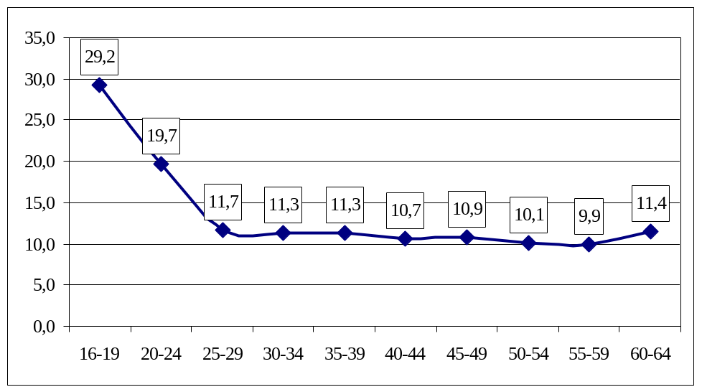

Meaning of varibles in model. Source of data

ep_et = Part-time employment over total employment (rate of part-time employment). LFS (INE).
mep_met = Part-time employment of woman over total employment of woman (rate of part-time employment of woman). LFS (INE).
time = a trend varible (1997=0). Own elaboration.
m_pt = Percentage of women over total population. LFS (INE).
m1644_pt = Percentage of women between 16 and 44 years old over total population. LFS (INE).
h1644_pt = Percentage of men between 16 and 44 years old over total population LFS (INE).
pmother = Percentage of mothers in accordance with LFS criterium over total femenine population. LFS (INE).
est_pt = Percentage of estudent in accordance with LFS criterium over total population. LFS (INE).
pss = Percentage of employment in service sector. LFS (INE).
isegre = Index of segregation. Own elaboration with data of LFS. INE.
prequar = Prevision of employment to next quarter from business men. Encuesta de Condiciones Laborales. Ministerio de Trabajo y Asuntos Sociales.
pi_d_et = Percentage of employment in R+D activities of total employment. Own elaboration with data of Estadísticas de Actividades de I+D and LFS. INE.
dhours = Diference between habitual hours and effective hours into employment. LFS (INE).
prod = Productivity (GDP/employment). Own elaboration with data of Contabilidad Regional de España y LFS (INE) (GDP/employment).
vac_et = Vacancies over total population. Registros de la Seguridad Social.INEM.
tnb = Gross birth rate. Basic demofigureic indicators. INE.
pmcoyhos = Percentage of women in business and hotel management activities. LFS (INE).

Table A.1. Average by regions of the analyzed variables (Source: LFS, second quarter 1997 and 2006).

 | 1997 | 2006
ep_et | 8,16389 | 12,20873
mep_met | 17,39125 | 23,53658
m_pt | 50.80055 | 50.50375
m1644_pt | 22.01119 | 21.25505
h1644_pt | 22.67023 | 22.44845
pmother | 38.10867 | 26.83822
est_pt | 0.1894563 | 0.1047226
pss | 60.33842 | 63.92953
isegre | 0.3698718 | 0.3653159
prequar | 0.7941176 | 1.164211
pi_d_et | 0.0000528 | 0.0000808
dhours | 1.36e-07 | 8.58e-08
prod | 0.4485807 | 0.4626817
vac_pt | 0.0019614 | 0.0011647
tbn | 9.200263 | 10.42580
pmcoyhos | 2.098011 | 3.574247
Table A.2. Panel estimation to regional distribution of part-time employment from supply, demand and both sides. (Source: Owner elaboration)

 | Supply side model |  | Demand side model |  | Both side model
 | Coef. | Std. Err.  (Sig.) | Coef. | Std. Err. (Sig.) | Coef. | Std. Err. (Sig.)
Time (1997=0) | 0,899 | 0,050*  (0,074) | 0,298 | 0,056**  (0,000) | 0,012 | 0,058  (0,828)
M_pt | 0,503 | 0,477  (0,292) | 1,165 | 0,424**  (0,006) | 0,829 | 0.356**  (0,020)
M1644_pt | 0,485 | 0,323  (0,134) |  |  | 0,784 | 0,327**  (0,017)
H1644_pt | -0,398 | 0,298  (0,184) |  |  | -0,649 | 0,293**  (0,025)
pmother | 0,362 | 0,040**  (0,000) |  |  | 0,445 | 0,058**  (0,000)
est_pt | 1,810 | 0,901**  (0,045) |  |  | 7,371 | 3,315**  (0,026)
pss |  |  | 0,044 | 0,436  (0,307) | 0,004 | 0,041  (0,906)
isegre |  |  | -0,769 | 4,850  (0,874) | -0,633 | 4,041  (0,875)
prequar |  |  | 0,098 | 0,155  (0,525) | 0,134 | 0,177  (0,292)
Pi_d_et |  |  | 0,340 | 0,512  (0,506) | 0,119 | 0,454**  (0,009)
dhours |  |  | 0,320 | 0,169*  (0,052) | 0,411 | 0,136**  (0,002)
prod |  |  | -0.339 | 0,099**  (0,001) | -0,025 | 0,093  (0,787)
vac_pt |  |  | 0,228 | 0,103**  (0,028) | 0,703 | 0.376*  (0,062)
Constant | -48,696 | 25,442*  (0,056) | -65,060 | 21,780**  (0,003) | -69,958 | 19,302**  (0,000)
Number of obs | 170 |  | 170 |  | 170
Wald Chi2 | 300,42 |  | 158,11 |  | 326,8
Prob>chi2 | 0,0000 |  | 0,0000 |  | 0,0000
* Significant with a probability of 90 %.
** Significant with a probability of 95 %.
Number of groups: 17 regions
Stata command:
iis ccaa2
tis year
xtreg ep_et time m_pt m1644_pt h1644_pt pmadre est_pt, re
xtreg ep_et time m_pt pss isegre pretri pi_d_et djornada prod9706 vac_pt, re
xtreg ep_et time m_pt m1644_pt h1644_pt pmadre est_pt pss isegre pretri pi_d_et djornada prod9706 vac_pt, re

Table A.3. Panel estimation to regional distribution of part-time employment of women from supply, demand and both sides. (Source: Owner elaboration)

 | Supply side model |  | Demand side model |  | Both side model
 | Coef. | Std. Err.  (Sig.) | Coef. | Std. Err. (Sig.) | Coef. | Std. Err. (Sig.)
Time (1997=0) | 0,035 | 0,108  (0,743) | 0,385 | 0,113**  (0,001) | 0,153 | 0,128  (0,232)
M_pt | 2,609 | 0,800**  (0,001) | 3,367 | 0,937**  (0,000) | 3,241 | 0,637**  (0,000)
bhm1644_pt | 0,263 | 0,663  (0,691) |  |  | 0,867 | 0,696  (0,213)
h1644_pt | -0,064 | 0,625  (0,918) |  |  | -0,694 | 0,625  (0,268)
pmother | 0,601 | 0,087**  (0,000) |  |  | 0,828 | 0,127**  (0,000)
est_pt | 4,394 | 1,583**  (0,006) |  |  | 1,311 | 7,352  (0,858)
pss |  |  | 0,134 | 0,094  (0,155) | 0,013 | 0,082  (0,871)
isegre |  |  | -3,432 | 9,840  (0,727) | -7,411 | 8,724  (0,396)
prequar |  |  | 0,159 | 0,310  (0,606) | 0,241 | 0,290  (0,406)
Pi_d_et |  |  | 3043,63 | 10466,95  (0,771) | 31755,11 | 9386,01**  (0,001)
dhours |  |  | 0,294 | 0,333  (0,376) | 0,303 | 0,297  (0,308)
prod |  |  | -0,467 | 0,199**  (0,019) | -0,182 | 0,212  (0,390)
Vac_pt |  |  | 0,443 | 224,35**  (0,048) | 0,234 | 831,89  (0,778)
Constant | -177,21 | 42,602**  (0,000) | -178,95 | 47,883**  (0,000) | -213,04 | 35,173**  (0,000)
Number of obs | 170 |  | 170 |  | 170
Wald Chi2 | 172,61 |  | 101,79 |  | 188,38
Prob>chi2 | 0,0000 |  | 0,0000 |  | 0,0000
* Significant with a probability of 90 %.
** Significant with a probability of 95 %.
Number of groups: 17 regions
Stata command:
iis ccaa2
tis year
xtreg mep_met time m_pt m1644_pt h1644_pt pmadre est_pt, re
xtreg mep_met time m_pt pss isegre pretri pi_d_et djornada prod9706 vac_pt, re
xtreg mep_met time m_pt m1644_pt h1644_pt pmadre est_pt pss isegre pretri pi_d_et djornada prod9706 vac_pt, re

REFERENCES

- ANXO, D. y STORRIE, D. (2000). The Job Creation Potential of the Service Sector in Europe. Employment and Social Affairs. European Commission.
- ARELLANO, M. y BOVER, O (2002) “Learning about migration decisions from the migrants: using complementary datasets to model intra-regional migrations in Spain”. Journal of Population Economics, Nº 15. pp. 357-380
- BECKER, G. (1981). Treatise on the Family. Harvard University Press. Cambridge.
- BERGMANN, B. (1986). The Economic Emergence of Women. Basic Books. Nueva York.
- BOLLÉ, P. (1997). “Part-time work: solution or trap? International Labour Review, 136, 4, 557-579.
- BOSCH, G. y LEHNDORFF, S. (2001). “Working-time reduction and employment. Experiences in Europe and economic policy recommendations”. Cambridge Journal of Economics, 25, 209-243.
- BUCHMUELLER, T. (1999). “Fringe benefits and the demand for part-time workers”. Applied Economics, 31, 551-563.
- BUDDELMEIER, H., MOURES, G. y WARD, M. (2003). The Determinants of Part-Time Work in EU countries. ECB.
- CARRASCO, C. (2006). “La Economía feminista: Una apuesta por otra Economía”. Capítulo 1 de María Jesús Vara (coord.). Estudios sobre género y economía. Editorial Akal. Madrid.
- CASTAÑO. C., IGLESIAS, C. et al (2004) “Indicadores laborales básicos de la situación de la mujer en España y sus regiones” Instituto de la Mujer
- COLUMBINO, U. y DI TOMMASO, M. (2000). “Identifying Demand and Suply of Part-Time Jobs using Personnel Data: An Application to Italy”. Labour, 14, 4, 609-622.
- CONNOLLY, S. y GREGORY, M. (2005). “Part-time work. A trap for Women´s careers? An Analysis of the Roles of Heterogeneity and State Dependence”. Discussion Paper number 245. Department of Economics. University of Oxford.
- DEVILLANOVA, C. y GARCÍA FONTES, W. (2004 ) “Migration across Spanish provinces: evidence from the social security records 1978-19992”. Investigaciones económicas. Nº 28 (3). Pp. 461-487.
- DOERINGER, PB. Y PIORE, MJ (1971).Internal Labour Market and Manpower Analysis. Lexington Books. Lexington.
- DOMÉNECH, R. Y GÓMEZ, V., (2005) “Ciclo Económico y Desempleo Estructural en la Economía Española”. Investigaciones Económicas, vol. XXIX. 2.
- DUCATEL, K. (1994). Employment and Technical Change in Europe. Working Organization, Skills and Training. Edward Elgar Publisher.
- EHRENBER, R.G., ROSENBERG, P. Y LI, J. (1988) “Part-time employment in the United Status”. En: Employment, Unmeployment and labour utilization, HART, R. (eds). Boston
- EUROSTAT. (http://epp.eurostat.ec.europa.eu/).
- EUWALS, R. y HOGERBRUGGE, M. (2004) “Explaining the groth of part-time employment: Factors of Suply and Demand” IZA Discusión Paper Series. Nº 1124. April. Bonn. Germany.
- EUWALS, R. y HOGERBRUGGE, m. (2004). “Explaining the Growth of Part-Time Employment: Factor of Suplí and Demand”. Discussion Paper 1124. IZA.
- FALLICK, B. (1999) “Part-time work and industry growth”. Monthly Labour Review, Vol 22. pp. 22-29
- FALLICK, B. (1999). “Part-time work and industry growth”. Monthly Labor Review, 22, 22-29.
- FREISEN, J. (1997). “The Dynamic Demand for Part-Time and Full-Time Labour”. Economica, 64, 255, 495-507.
- HAUSMAN, J. A. (1978) “A specification test in econometric” Econometrica Nº 46 pp. 1251-71
- HUMPHRIES, J. y RUBERY, J. (eds.)(1995). The Economics of Equal Opportunities. Equal Opportinities Commission. Manchester.
- JUHN, CH. y MURPHY, K.M. (1997). “Wage Inequality and Family Labour Suply”. Journal of Labor Economic, Enero, 72-97.
- O´REILLY, J (1997). “Labour Adjustments through Part-time Work”. Capítulo 19 de G. Schmid, J. O´Reilly y K. Schömann Internation Handbook of Labour Market Policy and Evaluations. Edward Elgar. MA EEUU.
- O´REILLY, J., CEBRIÁN, I. y LALLEMENT, M. (2000).Working-time Changes. Social Integration Through Transitional Labour Markets. Edward Elgar. EEUU.
- O´REILY, J. y BOTHFELD, S. (2002). “What Happens after Working Part-Time?. Integration, Maintenance or Exclusionary Transitions in Britain ad Western Germany”. Cambridge Journal of Economics, 26, 4, 409-439.
- PIORE, MJ. (1975). “Notes for a Theory of Labour Market Stratification “. En C. Edwards, M. Reich y DM. Gordon (eds.) Labour Market Segmentation. Lexington Books.
- PIORE, MJ. y BERGER, S. (1980). Dualism and Discontinuity in Industrial Scieties. Cambridge University Press.
- ROGER, M. y ROUX, S. (2000). “Flexibility versus Hiring Costs: The Demand for Part-Time Labor”. Discussion Parper 12/2000. INRA.
- RUBERY, J., FAGAN,C. y MAIER, F. (1997). “Occupational Segregation, Discrimination and Equal Opportunity”. Capítulo 14 de G. Schmid, J. O´Reilly y K. Shömann International Handbook of Labour Market Policy and Evaluation. Edward Elgar. EEUU.
- SCHMID, G. (1998). “Transitional Labour Markets: a new European employment strategy”. WZB Discussion Paper FSI 98-206. Berlin.
- SCHMID, G. y GAZIER, B. (Comps.) (2002). The Dynamics of Full Employment. Social Integration Through Transitional Labour Markets. Edward Elgar. MA EEUU.
- SIRVENT-GARCÍA, E. (2006). El empleo a tiempo parcial como herramienta para compatibilizar la flexibilidad laboral y la conciliación de la vida personal y laboral. Tesis Doctoral. Departamento de Economía Aplicada. Universidad del País Vasco. Bilbao.
- SPLETZER, J.R.( 1997). “Reexamining the Added Worker Effect”. Economic Inquiry, abril, 417-427.
- VVAA (2005). Más y mejor empleo en un nuevo escenario socioeconómico. Ministerio de Trabajo y Asuntos Sociales. Madrid.
- ZEYTINOGLU, I. (1992). “Reason form hiring part-time workers”. Industrial Relations, 31, 3, 489-499.

An exhaustive treatment of this subject can be found in Sirvent-García (2006).
The time period under consideration is 1987 to 2005 (second quarters). The countries under analysis are those which present a series of complete data for this time period; that is, the UE-15 countries, excluding France, Austria, Sweden and Finland. Ireland has been included, although the 2005 data is missing.
Another possible explanation is that jobs defined as women’s jobs are defined by their low productivity, which is the reason that employers prefer to fill them with women workers.
A very important methodological change occurred with respect to EPA in the year 2005, which implies the budding of part-time work beginning this year. Therefore, the differences between both periods can be seen as being influenced by this methodological change.
For more information on EPA methodology see www.ine.es.
The segregation index is calculated as 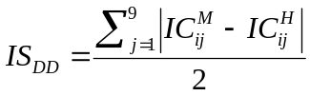 where IC^{M}_{ij} is the index of concentration of women or percentage of women in region i and in branch j over total employment in that branch and IC^{H}_{ij} is the same index of concentration but for the case of men.
In addition to the estimations presented in this article, estimations have been made taking into consideration variables such as the percentage of female employment over the sum total of employment, the percentage of employment in industry, in commerce and in hotel management, in public administration, expenditures in R&D that each region has in relation with its GDP, the growth of GDP, the one-year forecasting by employers, the rate of unemployment and the rate of women’s unemployment. All of these were discarded in the end due to problems with autocorrelation with other variables of the model, as well as to a lack of significance obtained.
As no significant results were obtained between the development of part-time employment and GDP growth we cannot establish in this way whether part-time employment is set up as an adjusting mechanism to economic cycles. Nor could this matter be extrapolated from the results obtained for the time variable given that the only thing that we can establish in connection with it is the tendency to grow or not to the extent that time advances and therefore this variable grows.
Given that the model is developed in a dynamic manner, it can be established that where there is greater organizational flexibility in the regions throughout time that favors hiring on a part-time basis.
A fact that can be tested by means of R² analysis or simply by testing the number of significant variables obtained.
Due to this the relations of causation are established in a more direct way, and the terms of error not being related with random disturbance has been achieved.

